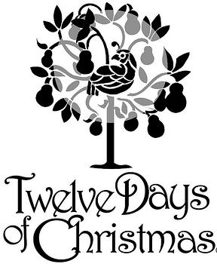
The twelve days of Christmas

On the first day of Christmas four ferrets fell from France.

On the second day of Christmas six snakes slithered south from Ç◊Sweden.

On the third day of Christmas the three things throw them.

On the fourth day of Christmas flocks of birds faked flying for freedom.

On the fifth day of Christmas four fins found flight.

On the sixth day of Christmas Sam sold six surprises so Santa’s stuck on stockings gifts.

On the seventh day of Christmas Seth smelled snacks sold by superstore.

On the eighth day of Christmas eleven evenly eaten eggs estimated gone.

On the ninth day of Christmas nobody knew now next to no one knows

On the tenth day of Christmas Timmy tattled on tom on Thursday, the 30th.

On the eleventh day of Christmas eight elephants eliminated extinction except eastern elephants.

On the twelfth day of Christmas twenty twinkling twins twisted twelve ankles.

